**Microprocessor Lab  
Lab Experiment No. 8**

Name: Ninad Rao Roll No. 53

**Aim**: Perform division of 16 bit number by 8 bit number.

**Instructions on how to use TASM**:

Steps for creating the program:

1. TASM is loaded
2. TASM < Edit - We will get an edit window
3. Type the program here
4. Save the file as <filename>.asm

Steps for running the program:

1. c:\tasm> Type here tasm filename

**c:\tasm> tasm <filename>.asm**

This will save the program, and the edit window with this file name will be seen.

1. c:\tasm> Linking the program

**c:\tasm> tlink <filename>.obj**

This will create an object file after linking.

1. c:\tasm> Now to execute the program and get to the result window

**c:\tasm> td <filename>.exe**

After execution, all the window options are present to check all registers, all memory locations and so on.

**Program to divide 16 bit number by 8 bit number**:

**Explanation**: Considering that a word of data is present in the AX register and byte of data is present in the BL register, we have to divide words in AX with the byte in BL. Using DIV instruction, divide the contents of two registers. Result of the division is stored in the AX register. AL contains the quotient and AH contains the remainder.

**Algorithm**:

**Step I:** Initialise the data segment.

**Step II:** Get the first number in AX register i.e. dividend.

**Step III:** Get the second number in BL i.e. divisor.

**Step IV:** Divide the two numbers.

**Step V:** Display the result.

**Step VI:** Stop

**Flowchart**:

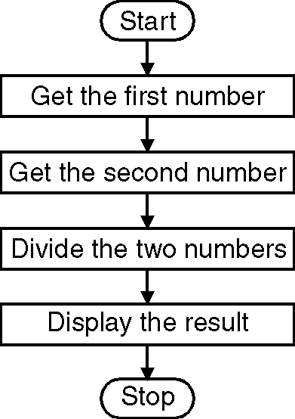

**Code**:

.model small

.data

a dw 000FH

b db 08H

.code

mov ax, @data ; Initialize data section

mov ds, ax

mov ax, a ; Load number1 in ax

mov bl, b ; Load number2 in bl

div bl ; Divide numbers. Quotient in al and Rem in ah

mov ch, 04h ; Count of digits to be displayed

mov cl, 04h ; Count to roll by 4 bits

mov bx, ax ; Result in reg bh

l2: rol bx, cl ; Roll bl so that msb comes to lsb

mov dl, bl ; Load dl with data to be displayed

and dl, 0fH ; Get only lsb

cmp dl, 09 ; Check if digit is 0-9 or letter A-F

jbe l4

add dl, 07 ; If letter add 37H else only add 30H

l4: add dl, 30H

mov ah, 02 ; Function 2 under INT 21H (Display character)

int 21H

dec ch ; Decrement Count

jnz l2

mov ah, 4cH ; Terminate Program

int 21H

end

**Output**:

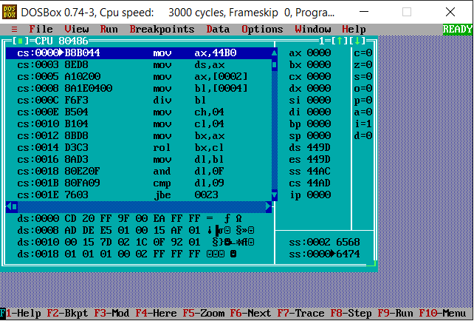

**Conclusion**: Thus, we have studied and understood the program to divide 16 bit number by 8 bit number.